Data Mining and Business Intelligence Lab
Experiment 1

Aim: To design Data Warehouse for given case study and perform ETL and OLAP
operations on it.

Theory:

➢ Data Warehouse Basics:
A data warehouse is a system that stores and analyses data from multiple sources to support
business intelligence, reporting, and analytics. It's a central repository that can store both
current and historical data.

Its key characteristics are:
1. Subject-Oriented: Focuses on specific business areas such as sales, finance, or customer data, rather than individual transactions.

2. Integrated: Consolidates data from multiple sources, ensuring consistency in naming
conventions, data formats, and structures.

3. Time-Variant: Stores both current and historical data to enable trend analysis and
Forecasting.

4. Non-Volatile: Data in a warehouse is stable and not frequently updated or deleted, ensuring a consistent analytical environment.

Benefits of a Data Warehouse:
• Improved Decision-Making: Enables businesses to make informed, data-driven decisions.
• Faster Query Performance: Optimized for complex queries and large data volumes.
• Historical Data Analysis: Supports trend analysis and forecasting.
• Data Consistency: Ensures a single source of truth by standardizing data from multiple
sources.
• Scalability: Can grow with increasing data volume and business needs.

➢ Data warehouse designing phases

The following are the key phases involved in data warehouse design:

1. Requirement Analysis
The first step in designing a data warehouse is understanding the business requirements and
the types of data that need to be stored and analysed. This involves discussions with
stakeholders to identify key performance indicators (KPIs), business metrics, and reporting
needs. It also includes an in-depth analysis of source systems to determine data availability,
volume, update frequency, and historical data requirements. Clear documentation of these requirements is crucial for ensuring that the data warehouse aligns with business objectives.

2. Conceptual Design
Once the requirements are gathered, the next phase is to create a high-level conceptual model of the data warehouse. This phase defines the scope and boundaries of the system, identifying the subject areas such as sales, finance, and customer data. The conceptual design provides an overview of how data flows from source systems into the warehouse and how different entities relate to one another.

3. Logical Design
In the logical design phase, the data model is created based on business requirements. The designer selects a schema, like a star schema with a central fact table linked to dimension tables or a snowflake schema with normalized dimensions. Fact tables store measurable data, while dimension tables provide descriptive attributes for filtering and grouping. Relationships,including primary and foreign keys, are established for efficient data retrieval.

4. Physical Design
After finalizing the logical structure, the physical design phase focuses on implementing the data warehouse in a database system. This involves selecting the appropriate database technology, whether on-premises, cloud-based, or hybrid. Security measures, such as user access controls and encryption, are also incorporated in this phase.

5. ETL (Extract, Transform, Load) Design
The ETL process is the backbone of a data warehouse, as it determines how data is collected, processed, and stored. In this phase, data is extracted from multiple source systems, including operational databases, flat files, and external APIs. The extracted data undergoes transformation, where it is cleansed, standardized, and enriched according to business rules.
Finally, the transformed data is loaded into the data warehouse, ensuring consistency and
accuracy. The ETL process also includes error handling mechanisms, data validation checks,
and scheduling for regular data updates.

6. Data Warehouse Implementation
With the ETL processes in place, the data warehouse is deployed for actual use. This phase involves setting up the database structure, configuring ETL pipelines, and loading initial historical data. Validation is performed to check for data integrity, ensuring that the warehouse correctly reflects business transactions.

7. BI & Reporting Layer Design
After implementation, the data warehouse is integrated with BI and reporting tools to create dashboards and analytical reports for data visualization. OLAP functionalities enable multidimensional analysis, allowing users to drill down into details. BI tools like Power BI, Tableau,and Looker provide decision-makers with meaningful insights for data-driven decisions.

8. Testing & Optimization
Before deploying the data warehouse into production, thorough testing is required to ensure that all components function correctly. Testings like unit and performance testing are carries out. Ensuring data accuracy, consistency, and completeness is crucial before the system goes live.

9. Deployment & Maintenance
Once testing is complete, the data warehouse is deployed into the production environment. Security policies, including user access control, encryption, and auditing, are enforced to protect sensitive business data. Ongoing maintenance involves monitoring system performance, ensuring data quality, and updating the warehouse as business needs evolve. well-maintained data warehouse continues to provide valuable insights and supports business intelligence initiatives for long-term success.

➢ Dimensional schemas:
Dimensional schemas define how data is structured in a data warehouse to optimize querying and reporting. These schemas organize data into fact tables (storing measurable business data) and dimension tables (storing descriptive attributes for filtering and grouping). The most common dimensional schemas are:

1. Star schema
The star schema is the simplest and most commonly used dimensional model. It consists of a central fact table containing numerical measures and multiple dimension that provide descriptive context. Each dimension table is directly connected to the fact table, forming a starlike structure.
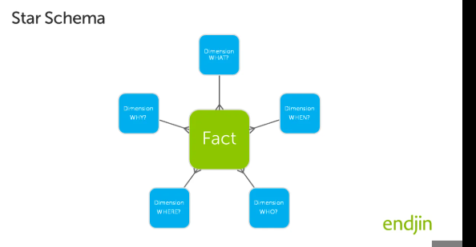

2. Snowflake schema
The snowflake schema is a normalized version of the star schema, where dimension tables are further broken down into sub-dimensions to eliminate redundancy. Instead of a single denormalized dimension table, related attributes are split into multiple linked tables.
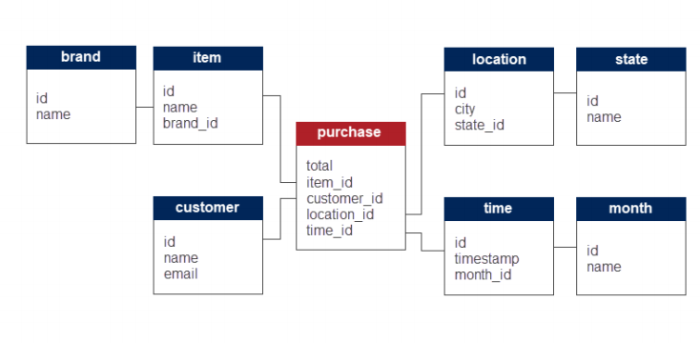

3. Fact constellation/galaxy schema

Fact Constellation is a schema for representing multidimensional model. It is a collection of multiple fact tables having some common dimension tables. It can be viewed as a collection of several star schemas and hence, also known as Galaxy schema. It is one of the widely used schema for Data warehouse designing and it is much more complex than star and snowflake schema.

Example:
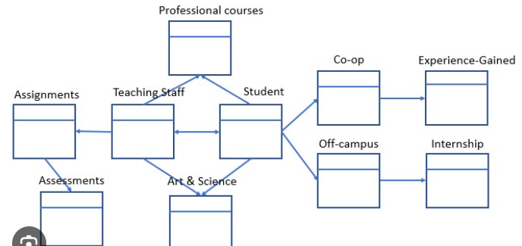

Extract, Transform, Load (ETL) – Detailed Theory

What is ETL?
ETL stands for Extract, Transform, Load and is a fundamental process in Data Warehousing. It is responsible for collecting data from multiple sources, transforming it into a structured format, and loading it into a target system like a Data Warehouse (DW).
ETL is crucial because raw data from various sources is often inconsistent, redundant, or unstructured. The ETL process ensures data quality, integrity, and consistency before storing it for analysis and reporting.

Phases of ETL Process
The ETL process consists of three primary phases:

1. Extraction (E) – Collecting Data
- Extraction is the process of gathering raw data from multiple source systems.
- Sources can include:
  - Relational Databases (e.g., MySQL, PostgreSQL, SQL Server)
  - Flat Files (e.g., CSV, Excel, JSON, XML)
  - APIs & Web Services (e.g., REST APIs, SOAP)
  - Cloud Storage (e.g., AWS S3, Google Drive)
  - Enterprise Applications (e.g., SAP, Salesforce)

2. Transformation (T) – Cleaning and Processing Data
- In this phase, the extracted data is processed, cleaned, and formatted to match the target system’s structure.
- This step is crucial because data from different sources may have inconsistencies, duplicates, and errors.

3. Loading (L) – Storing Data in the Target System
- Loading is the process of moving transformed data into the final Data Warehouse.
- The loading process should ensure data integrity and efficiency.

. OLAP (Online Analytical Processing)
OLAP is a category of software tools that allows users to analyze large amounts of data from multiple perspectives. It is used in Business Intelligence (BI) to support decision-making.

Key Features of OLAP:
- Multidimensional Data Analysis: OLAP organizes data into cubes that allow fast retrieval and analysis.
- Aggregation and Summarization: Users can analyze summarized data rather than raw transactions.
- Operations in OLAP:
  - Roll-up: Aggregating data to get a higher-level summary.
  - Drill-down: Breaking down summarized data into finer details.
  - Slice and Dice: Extracting a specific portion of data for analysis.
  - Pivot (Rotation): Changing the data view by rotating axes.

Types of OLAP:
- MOLAP (Multidimensional OLAP): Uses precomputed, multidimensional cubes for fast retrieval.
- ROLAP (Relational OLAP): Uses relational databases with complex queries to simulate OLAP.
- HOLAP (Hybrid OLAP): A combination of MOLAP and ROLAP for better performance.

Operations on OLAP Cubes
Once the cube is created, you can perform operations to analyze the data in different ways:

1. Roll-Up (Aggregation)
- It summarizes data by moving from detailed to higher levels.
- Example: If you have sales data for each day, you can roll up to see monthly or yearly sales.

2. Drill-Down (More Details)
- It is the opposite of Roll-Up; it moves from higher-level summary to detailed data.
- Example: You see total sales for a year → Drill down → See sales per month → Drill down more → See daily sales.

3. Slice (Extract One Part of the Cube)
- It selects data from a single dimension of the cube while keeping the other dimensions fixed.
- Example: You want to see only the sales for the year 2024 and ignore other years.

4. Dice (Extract a Smaller Cube)
- It selects data based on multiple conditions and creates a smaller sub-cube.
- Example: You filter sales for 2024 and only for action figures in Mumbai.

5. Pivot (Rotation of Cube)
- It changes the view of the cube to analyze data from different angles.
- Example: Instead of looking at sales by time first, you can rotate the view to see sales by location first.

Case Study: Car Sales Data Warehouse

Background
SpeedyWheels Inc. is a nationwide automobile dealership company that sells a variety of cars, including sedans, SUVs, and electric vehicles, through multiple dealerships across the country. The company wants to enhance its business intelligence capabilities by implementing a Car Sales Data Warehouse.
The primary objective is to analyze sales trends, customer preferences, and dealership performance to optimize inventory, improve marketing strategies, and enhance customer satisfaction. Currently, the company collects sales data from different sources, including point-of-sale (POS) systems, customer feedback forms, and dealership reports, but lacks a centralized system for data analysis.

Business Requirements
- Sales Performance Analysis
  - Track total car sales revenue across different locations.
  - Identify best-selling car models and brands.
  - Analyze sales trends over time (monthly, quarterly, yearly).
- Customer Insights & Behavior
  - Segment customers based on demographics (age, location, car preferences).
  - Analyze repeat purchases and customer loyalty.
  - Identify factors influencing customer purchases (brand preference, pricing, financing options).
- Dealer & Inventory Management
  - Monitor dealership performance by sales volume and revenue.
  - Track inventory levels and optimize stock based on demand.
  - Identify which car models are underperforming and need promotional offers.
- Marketing & Promotions Optimization
  - Analyze the impact of marketing campaigns on car sales.
  - Track sales during festive seasons and special discounts.
  - Recommend personalized promotions based on customer purchase history.
- Operational Efficiency
  - Predict demand for specific car models based on historical data.
  - Optimize supply chain management by forecasting inventory needs.

Fact Table:
- Fact_Car_Sales
  - Sale_ID (Primary Key)
  - Date_ID (Foreign Key)
  - Car_ID (Foreign Key)
  - Customer_ID (Foreign Key)
  - Dealer_ID (Foreign Key)
  - `
  - Sales_Amount (Measure)
  - Quantity_Sold (Measure)

Dimension Tables:
- Dim_Date
  - Date_ID (Primary Key)
  - Full_Date
  - Month
  - Year
- Dim_Car
  - Car_ID (Primary Key)
  - Model
  - Brand
  - Category
  - Engine_Size
- Dim_Customer
  - Customer_ID (Primary Key)
  - First_Name
  - Last_Name
  - Age
  - Location
- Dim_Dealer
  - Dealer_ID (Primary Key)
  - Dealer_Name
  - City

Creation of Table:
USE speedywheels;

-- Step 2: Create Dimension Tables

CREATE TABLE Date_Dim (
Date_ID INT PRIMARY KEY,
Date DATE,
Month VARCHAR(10),
Year INT
);

CREATE TABLE Car_Dim (
Car_ID INT PRIMARY KEY,
Model VARCHAR(50),
Brand VARCHAR(50),
Category VARCHAR(50),
Engine_Size VARCHAR(10)
);

CREATE TABLE Customer_Dim (
Customer_ID INT PRIMARY KEY,
Customer_Name VARCHAR(100),
Age INT,
Location VARCHAR(100)
);

CREATE TABLE Dealer_Dim (
Dealer_ID INT PRIMARY KEY,
Dealer_Name VARCHAR(100),
City VARCHAR(100)
);

-- Step 3: Create Fact Table
CREATE TABLE Car_Sales_Fact (
Sale_ID INT PRIMARY KEY,
Date_ID INT,
Car_ID INT,
Customer_ID INT,
Dealer_ID INT,
Sales_Amount DECIMAL(10,2),
Quantity_Sold INT,
FOREIGN KEY (Date_ID) REFERENCES Date_Dim(Date_ID),
FOREIGN KEY (Car_ID) REFERENCES Car_Dim(Car_ID),
FOREIGN KEY (Customer_ID) REFERENCES Customer_Dim(Customer_ID),
FOREIGN KEY (Dealer_ID) REFERENCES Dealer_Dim(Dealer_ID)
);

- Create DB SpeedyWheels:
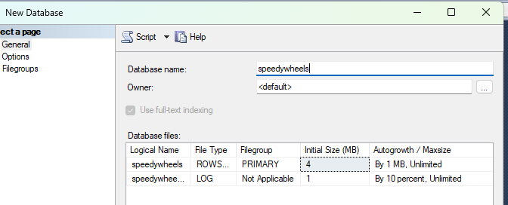

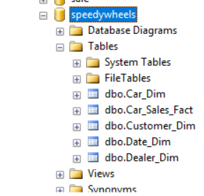

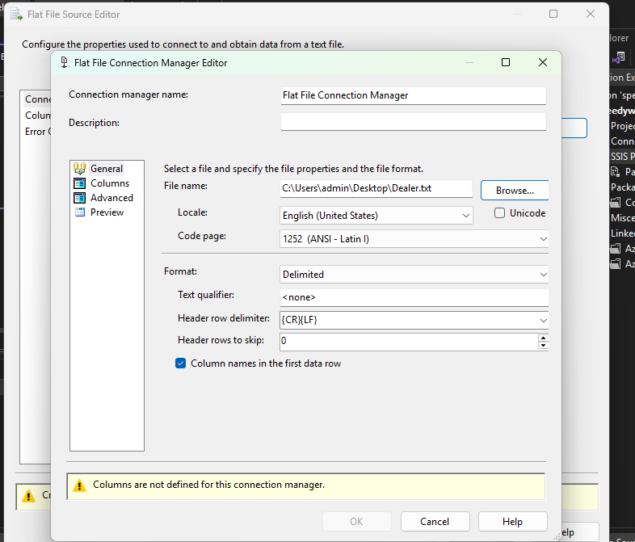

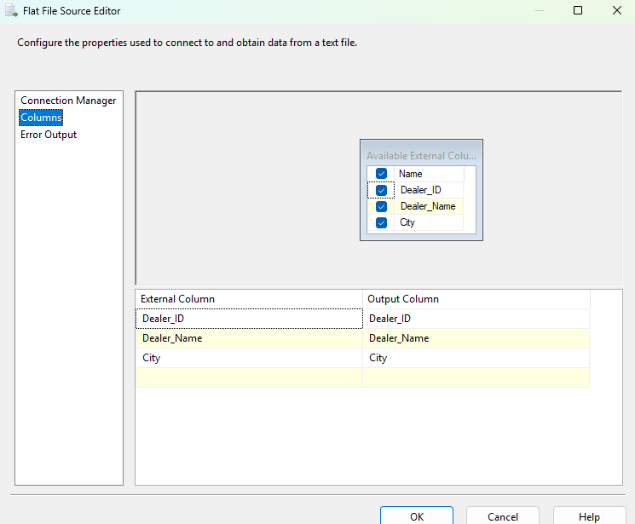
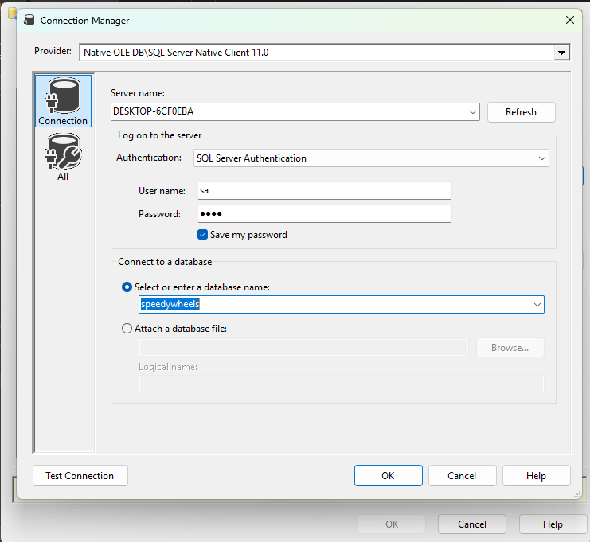

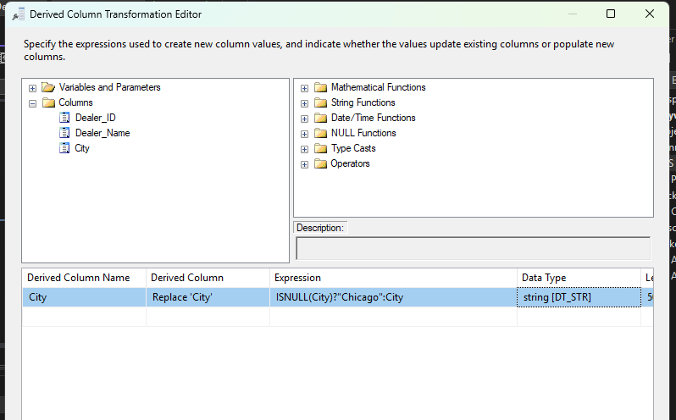

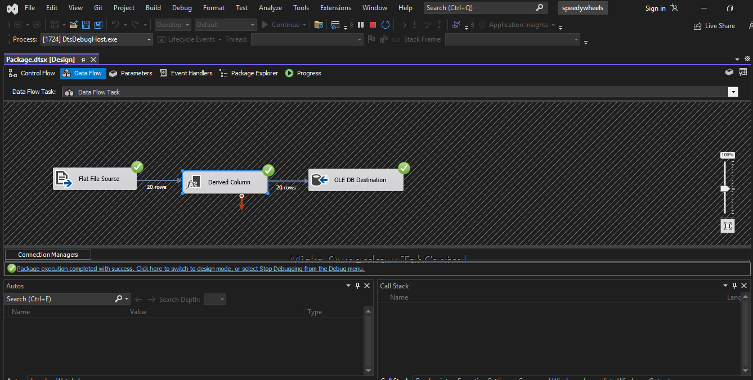

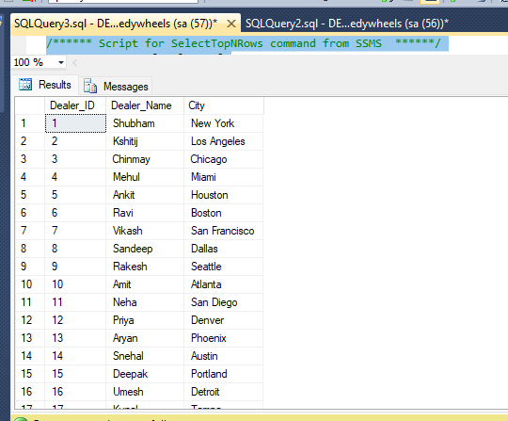

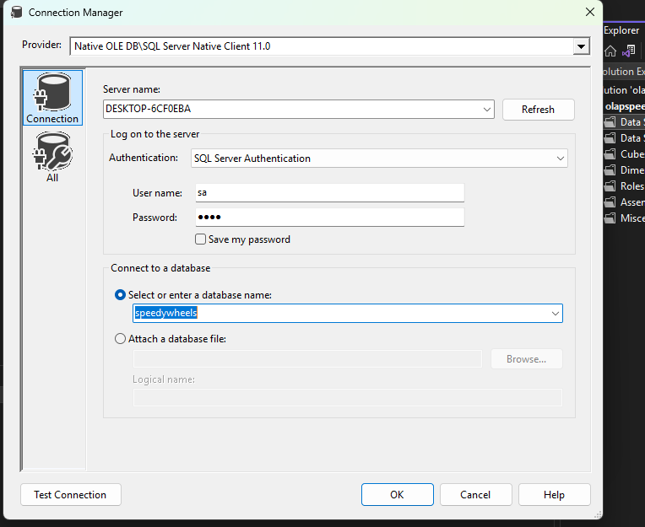

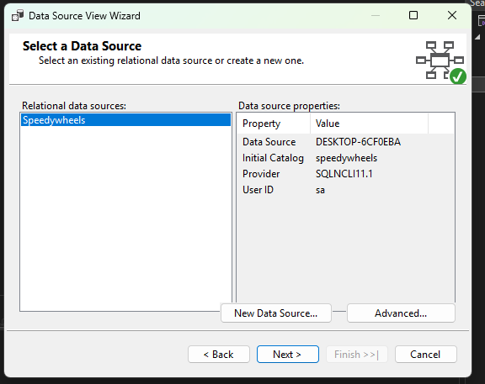

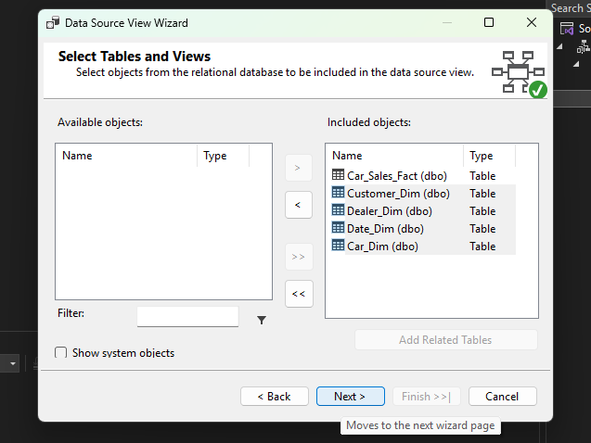

(star schema)
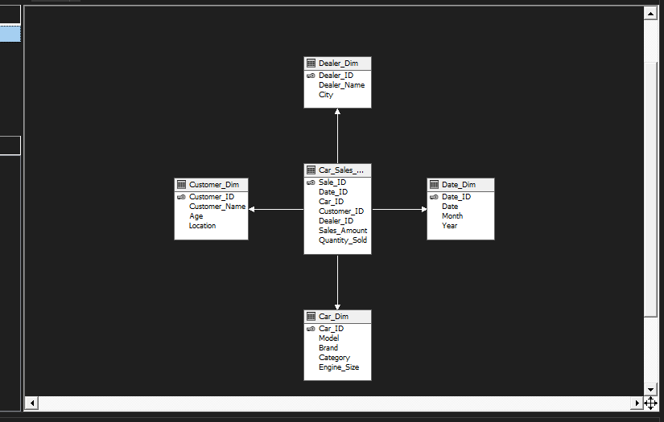

(Snow-Flake schema)
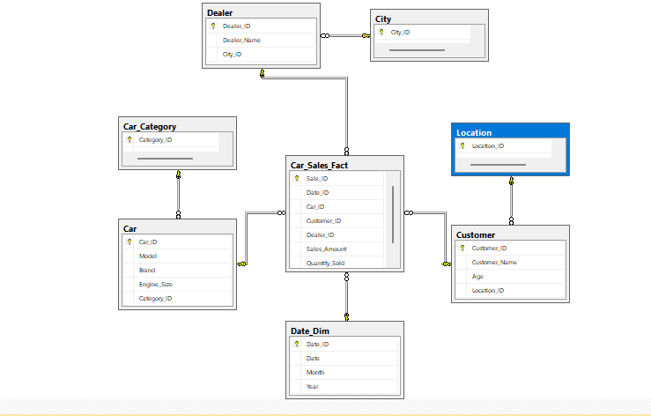

OLAP operations

Creating cube of our tables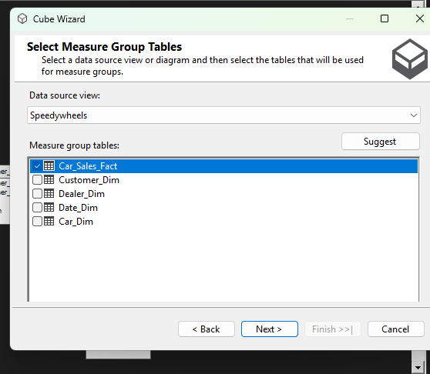

Putting the tables in the dimension view.
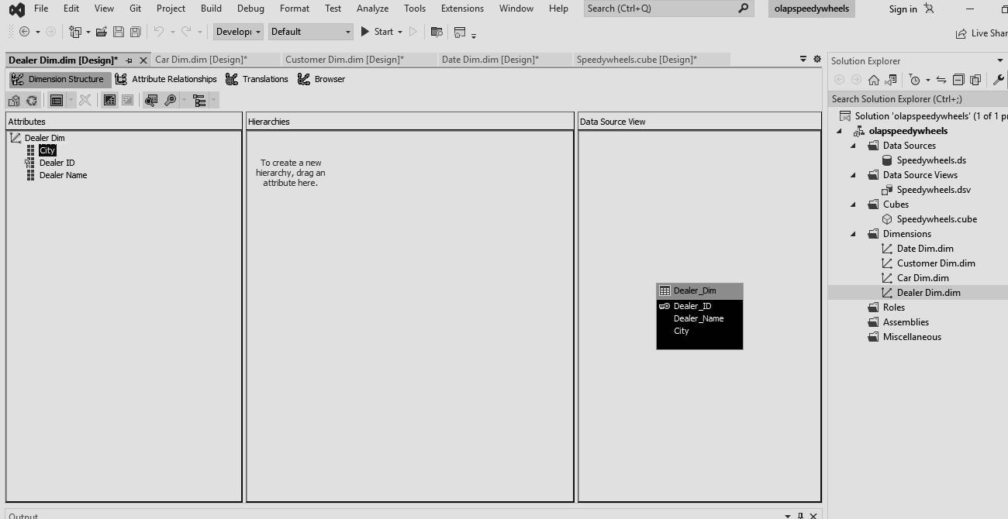

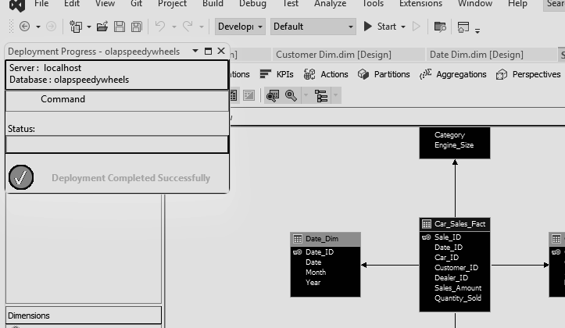

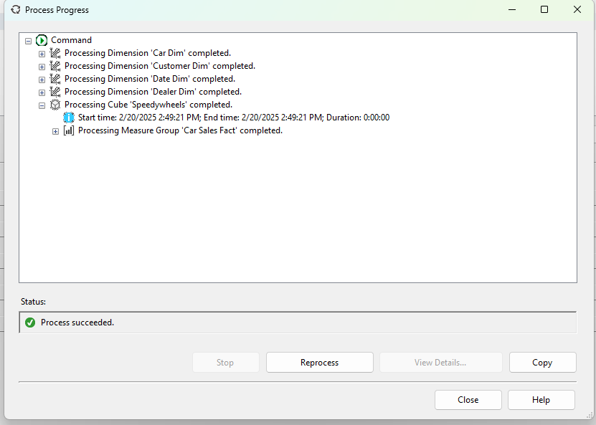

Example of roll up :
(we are finding the total quantiy of car sold in year 2024)

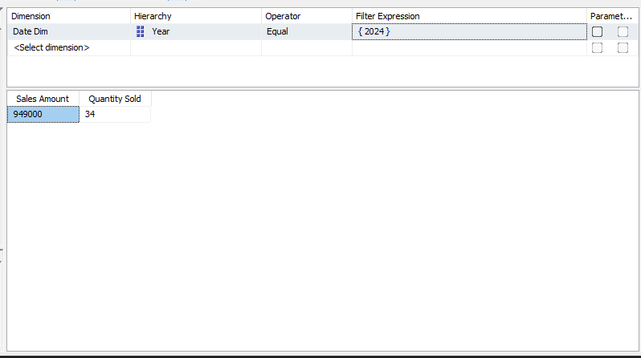

Example of drill down :
(we are finding the sales in particular month)
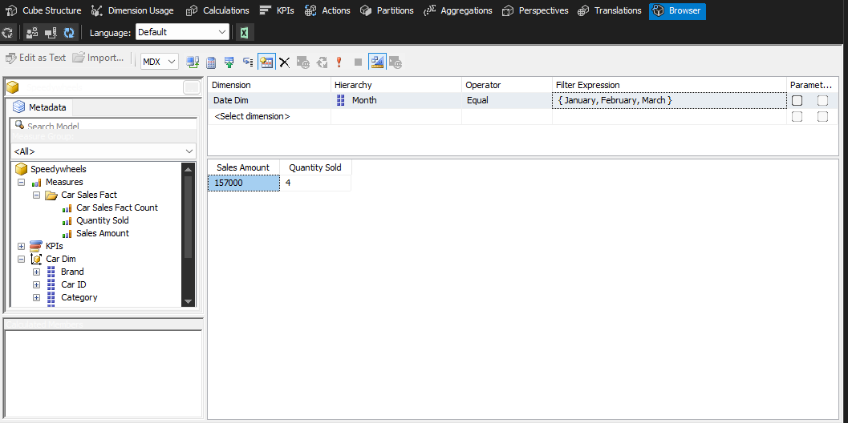
Slice: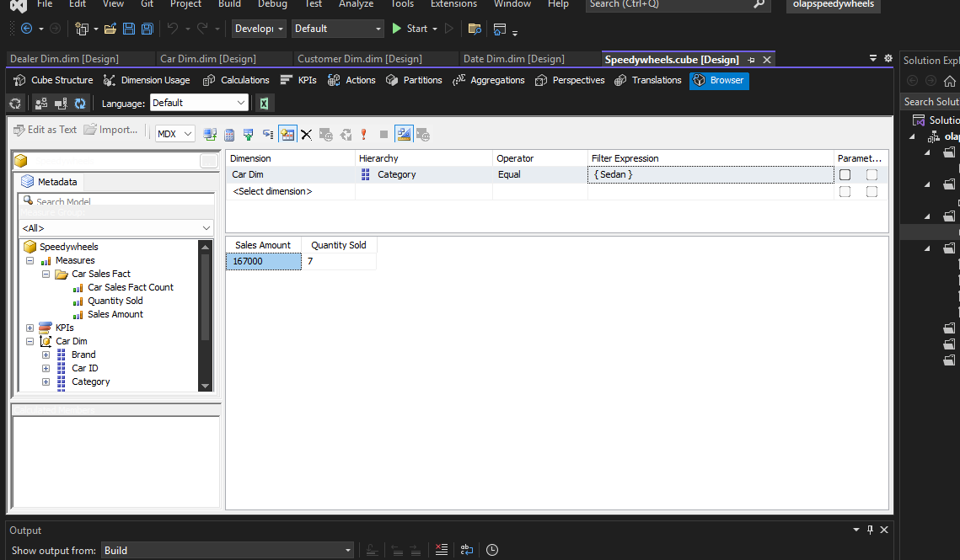

Dice :
Using Car_dim and Date_dim to know how many sedan models were sold in particular month
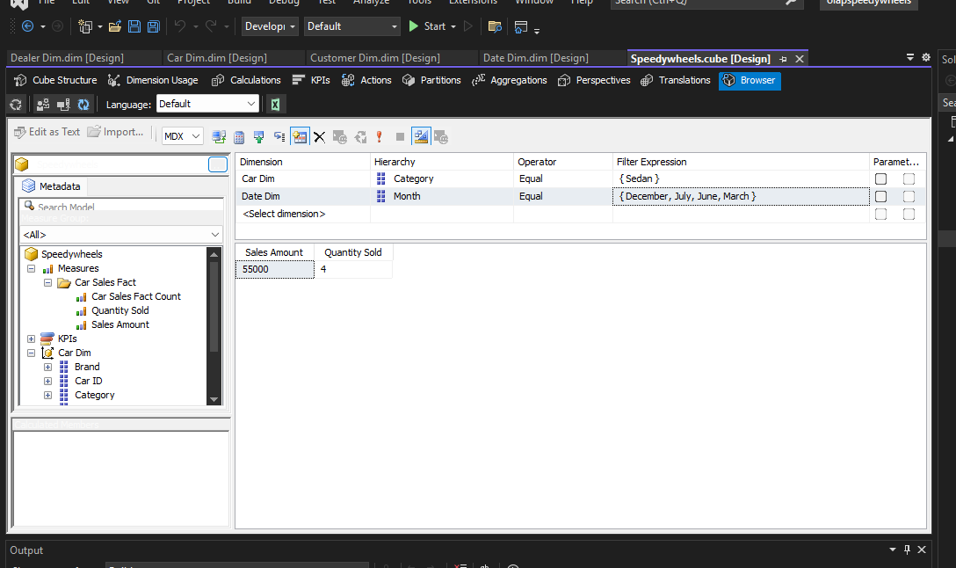

Pivot :

(before pivot)
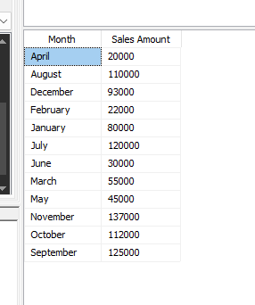

(after pivot)
